I designed the packaging on photoshop never having attempted to do this before it took a few prototypes to be able to figure out how to print off dimensions of a box and also how to layer things on photoshop. 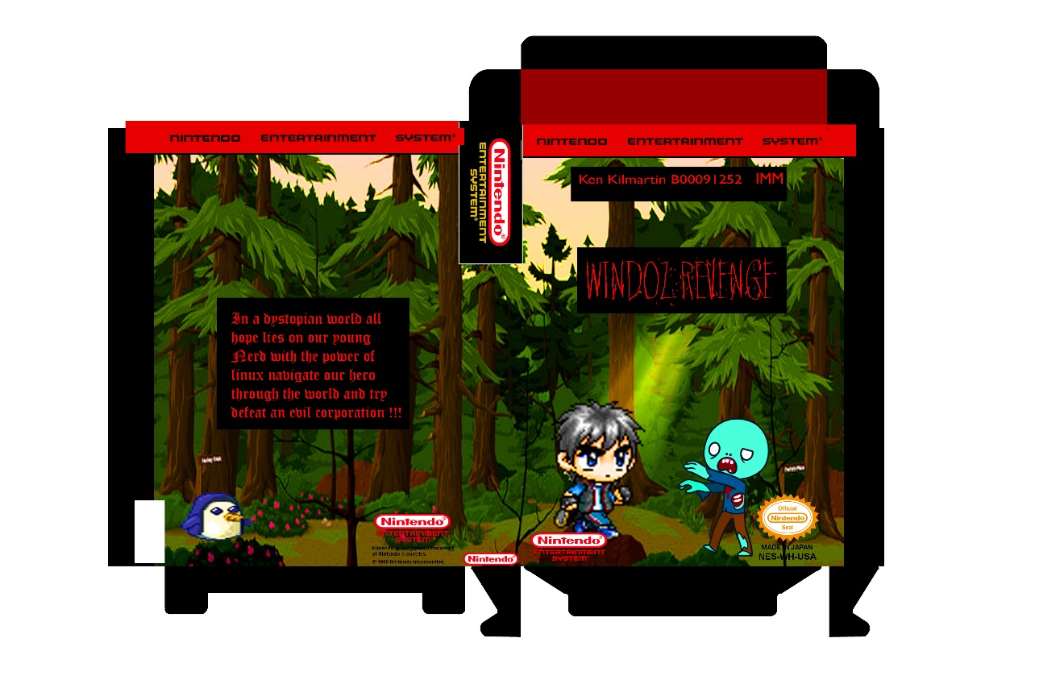After doing this I printed it out in reads and went home and cut it out luckily it all fit together nicely but realised after that the paper was a little flimsy so I reinforced with cardboard box to make more solid.

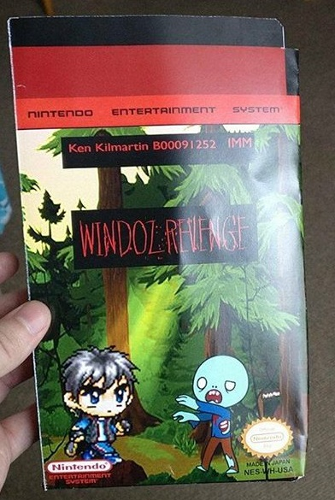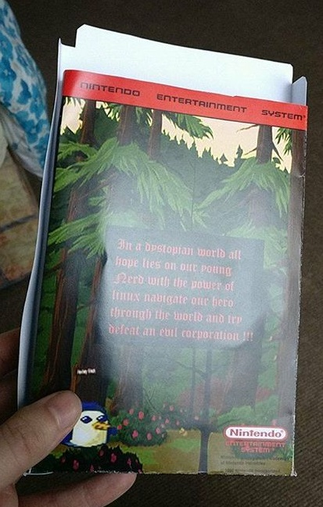

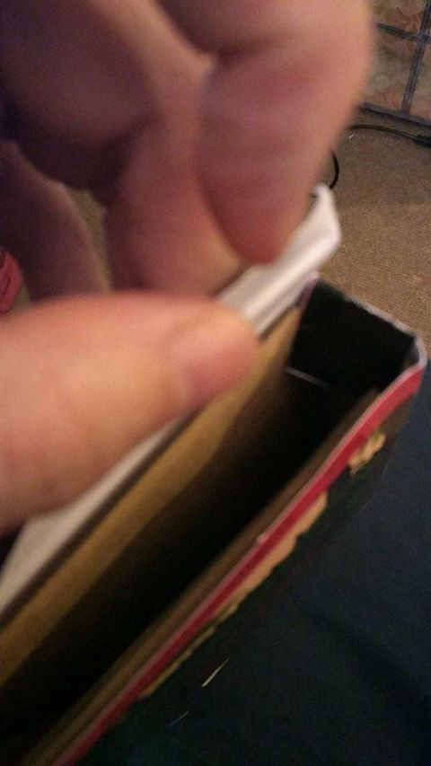Having hot glued the cardboard onto the inside I feel it gives a sturdier appearance.

Reference:

Got the logo and seal from this image

https://en.wikipedia.org/wiki/Star_Fox_(video_game)#/media/File:Star_Fox_SNES.jpg